Administrator Guide
jWebSocket Management Desk 1.0
Marcos Antonio González Huerta

1. Download application process
To install the jWebSocket Management Desk application you should proceed to download the jWebSocket server and client packages (Table 1). jWebSocket Management Desk is included in these packages.
Below in the Table 1, you can see the links containing the installation manuals of the jWebSocket server and client. In this URLs are also the links to download these packages.

Package | Size | Link
jWebSocket Server | 12.4 MB | http://enapso.com/?q=node/156
jWebSocket Client | 13.6 MB | http://enapso.com/?q=node/161
Table 1 - Link of the jWebSocket client and server packages.

It should also be considered as requirements for use, the following aspects:
- JDK 1.6 or higher installed on the server.
- A browser that supports WebSocket on the client.

2. Solution Roles
The application is safe; it has an authentication system with user and password. By default when it is installed brings an "admin" user with the password "admin" and the credentials to access to the application.

[ ROLE_ADMIN_MAINTENANCE ]: role or credential needed to access to the application.

3. Setting options

  - Default user configuration
The application has a configurable authentication module. By default is defined the user "admin", with a password "admin" which allows access to the application without making any changes to the settings.

  - Changing the default user settings
If you want modify the authentication module configuration, you must access the folder that contains the jWebSocket server settings. In the settings edit the file "system.xml" located in the folder "SystemPlugIn". This file contains the following default settings:
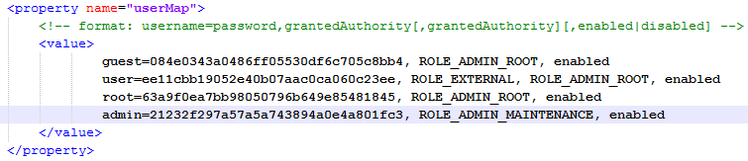
Note: for more information about the folder structure of the server, you can access to Folder Structure section.

To change the "admin" user you should consider the following aspects:
- The password must be encrypted with MD5.
- The credentials required for access to the application is "ROLE_ADMIN_MAINTENANCE".
- The user must be active for the authentication to work correctly.

  - Add a new user in the settings
To add a new user to the authentication module you must access to the settings file mentioned above and add a new line with the desired values. For example, if you want to add an "administrator" user with the "ROLE_ADMIN_ROOT" and "ROLE_ADMIN_MAINTENANCE" credentials the configuration file looks as follows:
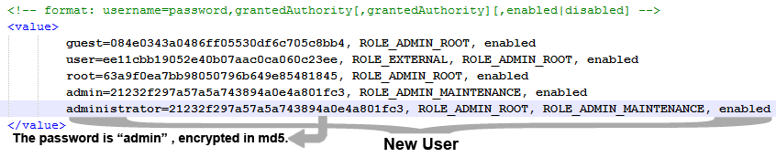
  - Default jWebSocket Management Desk configuration
If you wish to run the application jWebSocket Management Desk must first insert your settings, you can access to the jWebSocket main configuration file named “jWebSocket.xml”, search into the settings section called "plugins" and within this introduce the following configuration:
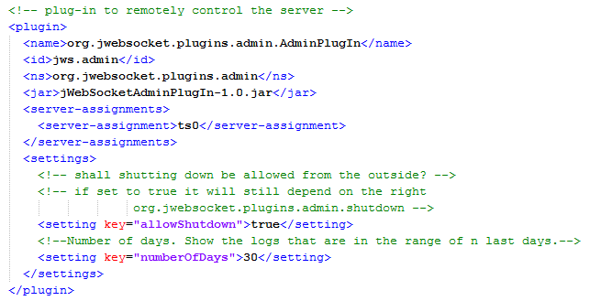
You should always check that this configuration is not already in the file jWebSocket.xml, if the configuration is inserted two or more times can affect server performance.

  - Configure the trace
The traces or records of actions executed by the application are stored in a log file. jWebSocket Management Desk allows you to configure how many days back you want to show you the traces. The default number is 30 days.
If you wish to change this default value, you can access to the jWebSocket main configuration file named “jWebSocket.xml”, search the plugin configurations whose identifier is "jws.admin" and change the value of property "numberOfDays" by the desired value.
For example, if you want to change the number of days to 10, the configurations would be as follows:
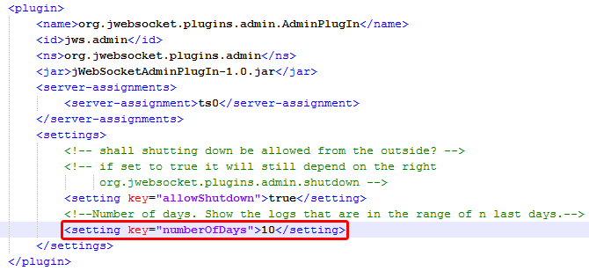

4. Switching on
To run the application you should start the jWebSocket server. In case that the server is running, you must restart the server to make effective the changes.

5. Structure of the “jwsMgmtDesk.xml” file
This file was created with the objective to save the settings needed for the application jWebSocket Management Desk. In its first version has two sections only "plugins" and "filters". These sections are meant to temporarily store the configurations of the plugins or filters are removed, so that if you wanted to add them later does not have to enter again.
This file is located in the configurations folder of jWebSocket server, in specific "/conf/AdminPlugin/jwsMgmtDesk.xml". Initially the file will be structured in the following way:
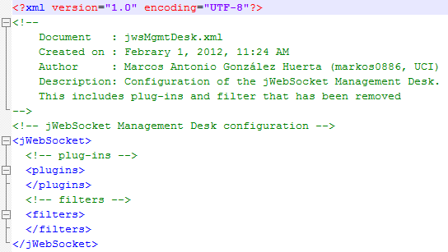

6. Management of the application
For the administration of jWebSocket Management Desk you can be supported with the user manual located in this link: http://enapso.com/?q=node/161.
In case of any problems during the application installation, contact with:
Alexander Schulze
Fon: +49 (0) 2407 902486
Fax: +49 (0) 2407 902487
Mail: a.schulze@jwebsocket.org

Would be nice tio have some examples of the plug-ins and filter configs of the jWebSocket.xml file. How do the xml settings look like? I think that should not be in the manual mine alone, but that is a specific doc for it and we all refer to it. Because we all have settings and this is an important part.

